KASHIPUR MICHEAL MADHUSUDAN MAHAVIDYALAYA

(PERSONAL PROFILE)

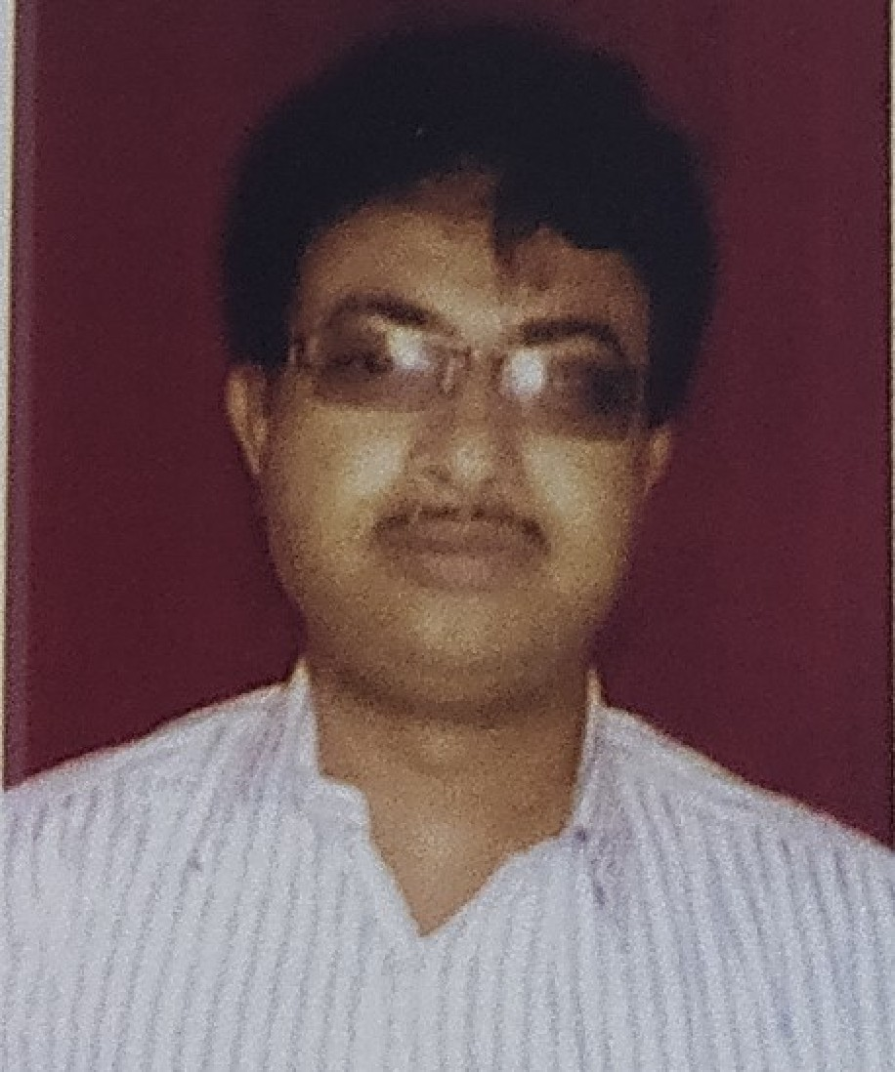
Name: ANIMESH SUPAKAR
Designation: SACT II & NSS Coordinator Department: POLITICAL SCIENCE Date of Joining: 01/08/2006
e-mail: animesh.polsc2006@gmail.com

Educational Qualification:
- Graduation: B.A(Hons)
- Post-graduation: M.A in Political Science
- M.Phil / Ph.D.-N/A

State Level / National / International Conferences /Seminars /Workshops /Webinar Attended:

Paper Presentations in Seminars / Conferences / Webinars
  - NA

Participation in Seminars / Conferences / Training Programmes / Workshop / Webinars
  - A One Day Seminar-Cum Workshop On “Value Education and Personality Development” organized by Kashipur M.M.Mahavidyalaya on 22/12/2017.
  - One Day International Seminar On “Vadu and Traditional Vadra-Culture” organized by Kashipur Michael Madhusudan Mahavidalaya on 14/09/2018.
  - International Webinar on “Covid-19: Challenges and Opportunities” organized by IQAC of Kashipur Michael Madhusudan Mahavidyalaya on 5th June, 2020.
  - A State Level Webinar on “Hool Diwas” organized by Dept. of Santali of Kashipur M.M.Mahavidyalaya on 30th June, 2020.
  - A Webinar on the occasion of International Day of Yoga topic was “Importance of Yoga in daily life.” Organized by Kashipur M.M.Mahavidyalaya held on 21st June, 2020.
  - One-Day National Webinar On “Recycling Waste : Management in Theory and Practice” organized by SAP Unit Dept. of Botany & IQAC, Kashipur M.M.Mahavidyalaya, Purulia held on 1st August, 2020.
  - One-Day National Webinar “Sustainable Development Goals and Covid-19” organized by Dept. of Economics, Kashipur M.M.Mahavidyalaya held on 09th September, 2020.
List of Research Papers published in National / International Journals / Books / Conference Proceedings with ISBN / ISSN / Impact Factor:

Books:
  - NA

Journals:
  - NA

Conference Proceedings:
  - NA
Awards and Recognition:
- NA

Areas of Specialization in Research / Teaching:
  - Specialization in Teaching: Sociology

  - In Research: NA
Teaching:
    - Theory: Indian Government and Politics, Political Theory, Western Political Thought, Comparative Politics and Government, Indian Political Thought, Public Administration, Political Sociology, International Relations.
    - Practical: NA
    - Excursion / Field Survey: NA

Invited Lecture / Foreign Visit:
- NA
Other Academic Activities:

- Board of Studies: NA
- Course Design: NA
- Paper Setter: NA
Administrative Activities:

- NSS Coordinator of Kashipur M. M. Mahavidyalaya since 2010.

Associated with Learned Bodies / Association / Society / Organization:

- NA

